Landrum Spine and Sport Chiropractic Confidential Patient History
235 Burley Ave. Hopkinsville, KY 42240 Phone: (270) 886-3136 Website: www.landrumdc.com

Date: / /______
Patient’s Full Name __________________________________________________________
Mailing Address: ________________________ City: __________________ State: _______ Zip: ___________
Home Phone: __________________ Cell Phone: ___________________ E-mail:_______________________
Date of Birth: _____/______/_____ Male Female
Social Security # ________ - ________ - _________
Married Single Widowed Divorced
Spouse’s Name: ____________________________________
Your Occupation: _________________________________
Employer: ____________________________
Family Physician: _____________________________ City: __________________ State: ____________
Previous Chiropractic Care: Yes No
If Yes, for what? ________________________________ Chiropractor’s Name: ____________________________
Who can we thank for the referral? (Physician or Friend’s Name)______________________________
Type of care you are interested in: Pain relief only Healing of current condition
What is your long-term goal from treatment (ex. play a round of golf)? ____________________________
Is Today’s Visit Due To An Auto Accident or Work Related Injury: Yes No

HEALTH HISTORY:
- Have you ever experienced the problem before for which you are consulting us: Yes No

- Have you ever had a stroke or issues with blood clotting? Yes No
- Have you experienced dizziness, unexplained fatigue, weight or blood loss? Yes No

- Have you ever had any major illnesses, injuries, broken bones, hospitalizations, accidents, surgeries? Yes No
Date | Injury/Fracture/Illness/Surgeries | Treatment

Do you or have you ever had any problems with the following areas?
- ____ Headaches 7. ____ Muscles 13. ____ Allergies
- ____ Ears, Nose, Mouth, Throat 8. ____ Nerves 14. ____ Psychological/Emotional
- ____ Heart 9. ____ Joints/Bones Females Only:
- ____ Lungs/Breathing 10.____ Skin 15 .____Gynecological/Menstrual/Breast
- ____ Intestines/Bowels 11.____ Internal Organs Males Only:
- ____ Urinary 12.____ Blood 16. ____ Prostate/Testicular/Penile
Please explain YES answers:_________________________________________________________________________________
_________________________________________________________________________________________________________

Yes No
Do you exercise? ____________ Times per week?_____________
Do you consume alcohol? How many drinks per week? ____________________
Do you get adequate sleep? If no, explain: ____________________________

Recreational Activities (Hobbies): __________________________________________________________________

CURRENT ISSUES:
Chief Complaint: _____________________________________________________________________
Secondary or Related Complaint(s), if any: __________________________________________________
When and how did your symptoms begin: ___________________________________________________
What self-treatment or medication, if any, have you tried: _______________________________________
Position or activities that cause increased pain: _______________________________________________
Position that you sleep in a majority of the night: ____________________ Number of pillows:___________
List any imaging (X-ray, MRI, CT) recently taken:____________________________________________

Please mark areas of pain using these codes:
+++ Burning ### Dull/Ache *** Numbness/Tingling === Throbbing 000 Stabbing/Sharp
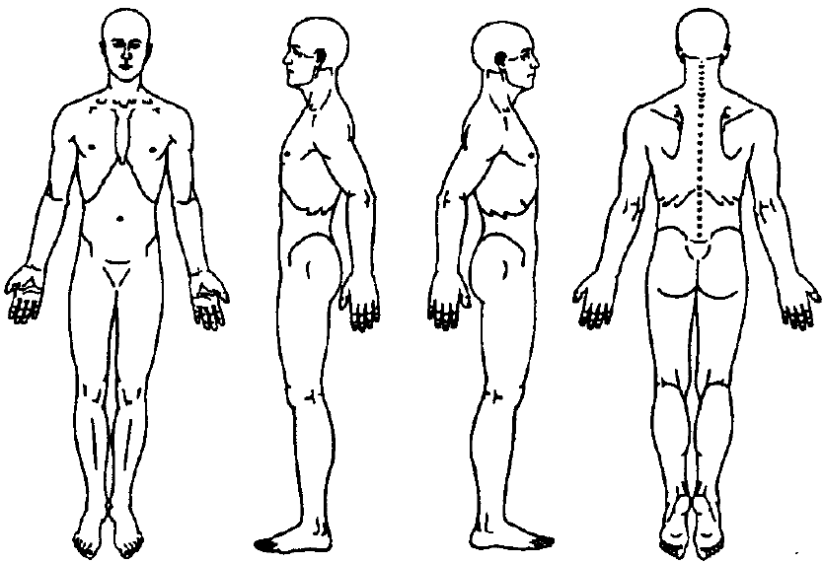

SEVERITY OF PAIN
List region of pain and circle the number which represents the intensity of your pain
- Complaint: _________________________ (No pain) 0-1-2-3-4-5-6-7-8-9-10 (Unbearable pain)

- Complaint: _________________________ (No pain) 0-1-2-3-4-5-6-7-8-9-10 (Unbearable pain)

Electronic Health Records Intake Form
This form complies with CMS EHR incentive program requirements

First Name:_________________________ | Last Name:_________________________
Email address: _________________@_________________
Preferred method of communication for patient reminders (Circle one): Email / Phone / Mail
DOB: __/__/____ Gender (Circle one): Male / Female Preferred Language: __________________
Smoking Status (Circle one): Every Day Smoker / Occasional Smoker / Former Smoker / Never Smoked
Smoking Start Date (Optional): __________________

Family Medical History (Record one diagnosis in your family history and the affected relative)
Diagnosis  (Write in below) | Father | Mother | Sibling: (___________) | Offspring: (___________)
Example:  Heart Disease |  | X
Race (Circle one): American Indian or Alaska Native / Asian / Black or African American / White (Caucasian) Native Hawaiian or Pacific Islander / I Decline to Answer
Ethnicity (Circle one): Hispanic or Latino / Not Hispanic or Latino / I Decline to Answer

Are you currently taking any medications? (Include regularly used over the counter medications)
Medication Name | Dosage and Frequency (i.e. 5mg once a day, etc.)

Do you have any medication allergies?
Medication Name | Reaction | Onset Date | Additional Comments
□ I choose to decline receipt of my clinical summary after every visit (These summaries are often blank as a result of the nature and frequency of chiropractic care.)
Patient Signature: _____________________________________________ Date: ________________
For office use only
Height: _________ Weight:____________ Blood Pressure:______ /______

INFORMED CONSENT
Medical doctors, chiropractic doctors, osteopaths, and physical therapists that perform manipulation are required by law to obtain your informed consent before starting treatment.
I, _____________________________________, do hereby give my consent to the performance of conservative noninvasive treatment to the joints and soft tissues. I understand that the procedures may consist of manipulations/adjustments involving movement of the joints and soft tissues. Physical therapy and exercises also may be used. Although spinal and extremity manipulation/adjustment is considered to be one of the safest, most effective forms of therapy for musculoskeletal problems, I am aware that there are possible risks and complications associated with these procedures as follows: soreness/bruising, dizziness, fracture, stroke, joint injury, and physical therapy burns. Tests have been or will be performed on me to minimize the risk of any complication from treatment and I assume these risks.
TREATMENT RESULTS
I also understand that there are beneficial effects associated with these treatment procedures including decreased pain, improved mobility and function, and reduced muscle spasm. However, I appreciate there is no certainty that I will achieve these benefits.
I realize that the practice of medicine, including chiropractic, is not an exact science and I acknowledge that no guarantee has been made to me regarding the outcome of these procedures.
I agree to the performance of these procedures by my doctor and such other person of the doctor’s choosing.
ALTERNATIVE TREATMENTS AVAILABLE
Reasonable alternatives to these procedures have been explained to me including rest, applications of home therapy, prescription or over-the-counter medications, exercises and possible surgery.
Medications: Medication can be used to reduce pain or inflammation. I am aware that long-term use or overuse of medication is always a cause for concern. Drugs may mask pathology, produce inadequate or short-term relief, undesirable side effects, physical or psychological dependence, and may have to be continued indefinitely. Some medications may involve serious risks.
Rest/Exercise: It has been explained to me that simple rest is not likely to reverse pathology, although it may temporarily reduce inflammation and pain. The same is true of ice, heat, or other home therapy. Prolonged bed rest contributes to weakened bones and joint stiffness. Exercises are of limited value but are not corrective of injured nerve and joint tissues.
Surgery: Surgery may be necessary for joint instability or serious disc rupture. Surgical risks may include unsuccessful outcome, complications, pain or reaction to anesthesia, and prolonged recovery.
Non-treatment: I understand the potential risks of refusing or neglecting care may include pain, scar/adhesion formation, restricted motion, possible nerve damage, increased inflammation, and worsening pathology. The aforementioned may complicate treatment making future recovery and rehabilitation more difficult and lengthy.
I have read or had read to me the above explanation of chiropractic treatment. Any questions I have had regarding these procedures have been answered to my satisfaction PRIOR TO MY SIGNING THIS CONSENT FORM. I have made my decision voluntarily and freely.
To attest to my consent to these procedures, I hereby affix my signature to this authorization for treatment.
_______________________________________Signature of Patient Date ____________________
_______________________________________Signature of Parent (If a minor) Date ____________________

_______________________________________Signature of Witness Date ____________________

Financial/Privacy Policy and Disclaimer
Insurance Verification
- Insurance verification is not a guarantee of payment. Verification is not only a quote of patient benefits.
Insurance companies review charges individually and make payment accordingly. Charges not covered by insurance are the patient’s responsibility and due within 30 days of billing.
Collection of Patient Balance
- Co-payments and Co-insurance is the patient’s responsibility and will be collected at the time of service.
- If an “Explanation of Benefits” or EOB shows the patient has an outstanding responsibility for any reason, the patient will receive a bill outlining the outstanding charges. Payment is due within 30 days of receipt of the bill.
- In the event a bill is disputed, you must notify us within 30 days. If you do not notify us within that time, the bill will be presumed valid and due. In the event any further action is necessary to collect an unpaid bill, charges for the collection of delinquent accounts, including collection agency, court costs and or reasonable attorney’s fees will be added to the total balance.
- All balances remaining unpaid after 30 days, unless you have already worked out a payment plan with office manager, may be reported to a credit bureau and affect your credit rating.
Appointments
- If unable to keep an appointment, as a courtesy to our staff and other patients please give 24-hour notice. If it is a continual problem there will be a $20 charge towards your account each visit that is missed and $35 charge for each decompression therapy missed. The patient will be responsible for payment.
HIPPA Private Policy
- Attached to the patient information packet at the back of these forms is the HIPPA Notice of Privacy Practices Policy for you.
- By signing below, the patient acknowledges that he/she has received the HIPPA Private Policy and that he/she understands and will comply with our financial policies.
Authorization and Assignment
In consideration of your undertaking to care for me, I agree to the following:
You are authorized to release any information you deem appropriate concerning my physical or emotional condition, health, history, or billing and payment history to any insurance company, attorney, or adjuster for the purpose of any claim for reimbursement of charges incurred by me.
I authorize my attorney and/or any insurance company to make direct payment to you of settlement proceeds.
I hereby assign and transfer to you the cause of action that exists in my favor against any insurance company obligated by contractual agreement to make payment to me or to you for the charges made for your service. I authorize you to prosecute said action either in my name. I further authorize you to compromise, settle, or otherwise resolve said claim as you see fit. I understand that whatever amounts you do not collect from insurance companies, whether it be all or part of what was due I personally owe to you.
I further agree that this Authorization and Assignment is irrevocable until all money owed to you (Landrum Spine and Sport Chiropractic) are paid in full.

_______________________________________Signature of Patient Date ____________________

